

<A guide to Game of Thrones>

Project Report

DT228

Computer Science

**<Christopher Brady>**

School of Computing

Dublin Institute of Technology

**<07/12/2017>**



Declaration

I hereby declare that the work described in this dissertation is, except where otherwise stated, entirely my own work and has not been submitted as an exercise for a degree at this or any other university.

Signed:

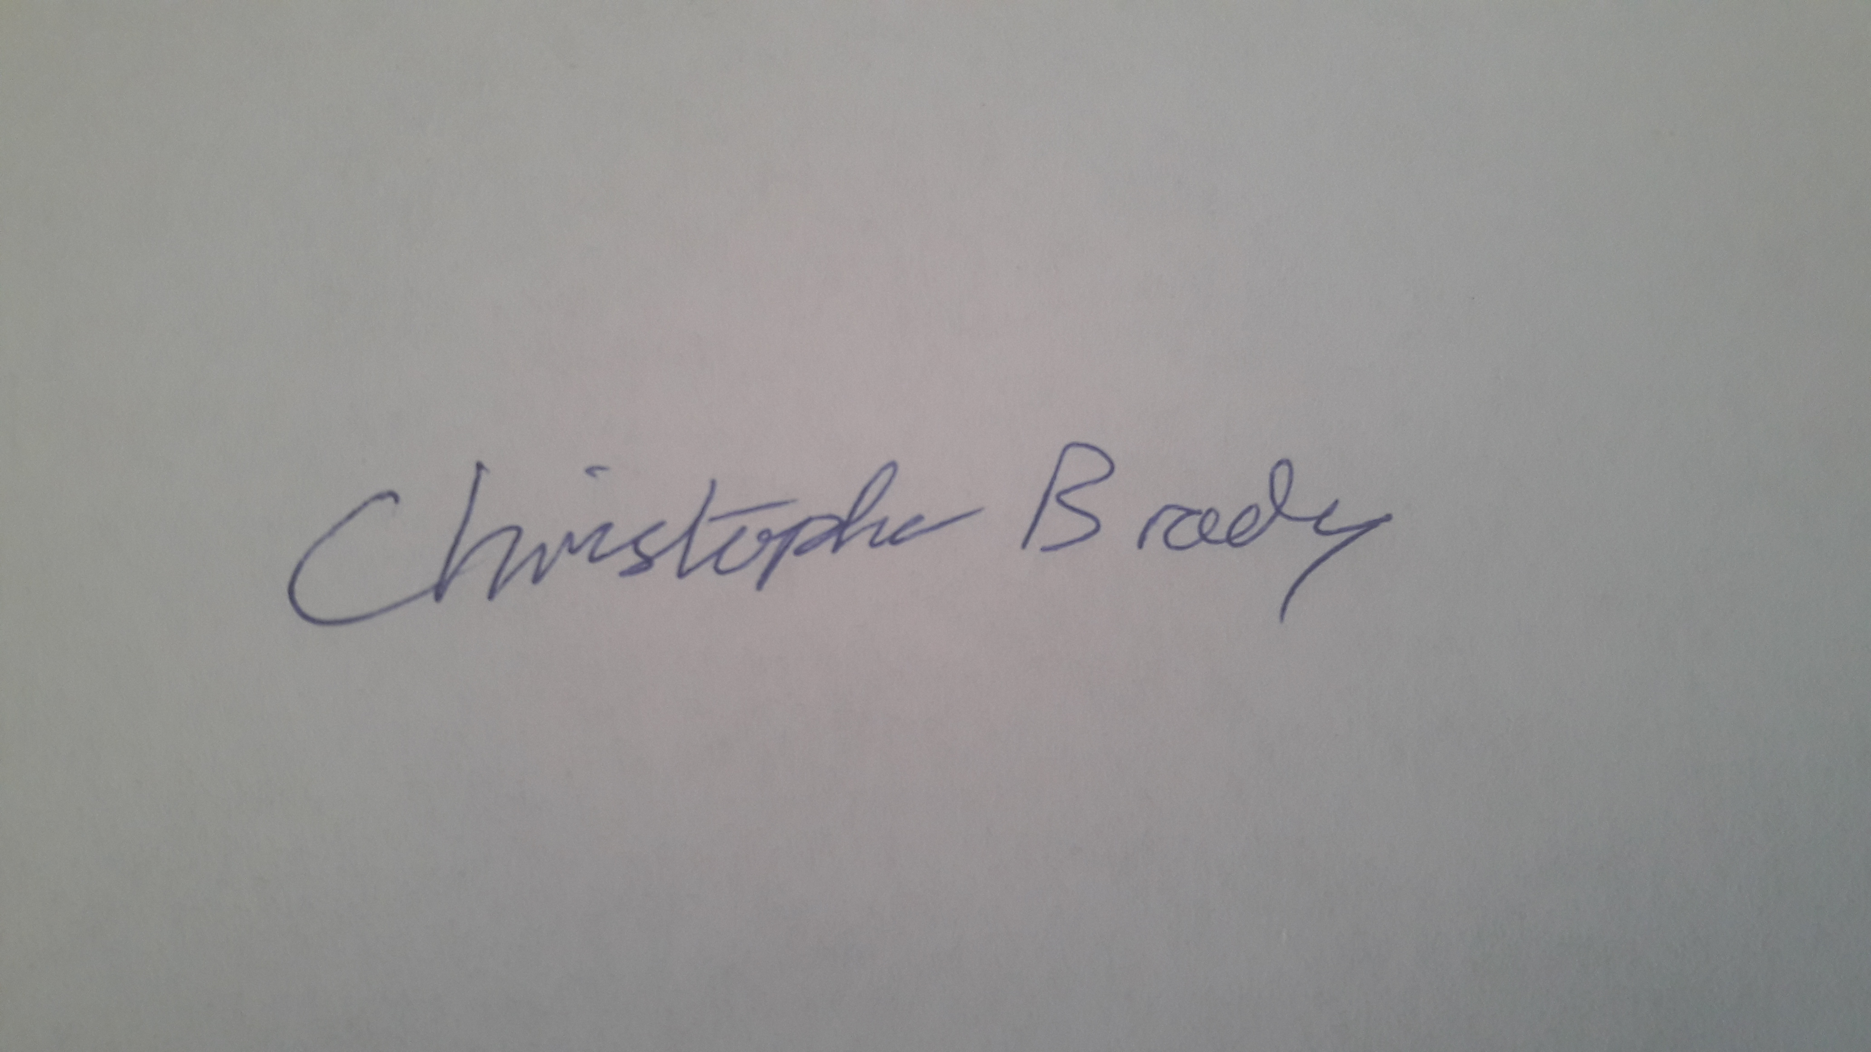

_________________________

<Student Name>

<Date> 07/12/2017

Table of Contents

*1.* Problem Description 4

*2.* Research 4

*3.* Technology Selection and Site Architecture 4

*4.* Low Fidelity Prototype 4

*5.* Development Plan 4

*6.* Testing Plan 4

*7.* Site Evaluation 4

*8.* Deployment 4

Appendices 5

**Problem Description**

The website I completed my project on is called “A guide to Game of Thrones”. The website includes a detailed insight into the hit television series, perfect for anyone thinking of starting the show. The appearance of the website is linked with the show itself too. I chose a blood splattered background to represent the gruesomeness of the show and I used a dark red image as the header background to stick with the blood theme and make the title pop.

**Home Page**

The websites home page includes 5 main parts. The first key element is the menu button which is included on every page of the website. It is a dropdown menu to appear cleaner and less cluttered, and its functionality allows the user to navigate through the website’s pages. Also included on the first page are two large paragraphs, which described the purpose of the website and then also gave a brief description on the television show itself. They are positioned centrally to the page and placed one on top of the other to have a spacious appearance and to be read in chronological order. Also included on the page is an image rotator showing some iconic scenes of the show and beside this a registration form to allow the users to sign up to an online forum.

**Setting and Background**

The second page of the website is on the Setting and Background of the television series. This page taught the user about the history behind the show and story. I included a paragraph on the setting and a picture of a map alongside. Then the page includes a brief description of the families within Game of Thrones, which is something that would be very helpful to new watchers of the show. For appearance I styled each of the paragraphs the same but included a picture, in line with the paragraph, of each of the families/houses sigil. At the bottom of the page there is two more paragraphs referencing the start of the show and some of the mythical creatures that are in the show. Due to the website being against spoilers, I tried to give away as little detail as possible.

**Characters**

The purpose of the third page of the site is to allow the user to familiarise themselves with some of the main characters of the show. This way they would have a brief idea of who each person was when starting but without knowing too much. This way the user can follow the show easier and still be surprised by its characters. I structured this page with paragraph boxes on each character and an image alongside to add some visual for the user.

**Books vs Show**

The fourth page of the website addresses the fact that there is both a novel series and television of the show. I chose to give a brief description of both and also included a paragraph on the differences between them. At the end I added an online poll for the user to choose which they would prefer to watch. This links to a real poll website and shows the results which would be intriguing for the user.

**News**

The final page on the website was the news section. This included a reference to when the show and books would next be released and in the future will include more up to date news. Also on the page is an iframe with the season 1 trailer of Game of Thrones. This is a way of encouraging the user that final step to watch the show.

**Archetypical users and problem that the site solves:**

The Archetypical users of this site would primarily be people that are considering to watch the series but want a quick insight before they start. The website shows them what the show is about and why they should watch it, all without giving too much away. The main aim of the website is to encourage more and more people to watch the show, and this simple website does this and give the user a head start to starting this!

**Research**

For this website I had to do a lot of research to ensure I was giving out correct information to the users, this included, names of places, characters and other details. To do this, I used the HBO website on Game of thrones (“https://www.hbo.com/game-of-thrones”), a game of thrones wiki (“http://gameofthrones.wikia.com/wiki/Game_of_Thrones_Wiki”) and finally the Wikipedia on Game of Thrones (“https://en.wikipedia.org/wiki/Game_of_Thrones”). For the layout of my website I used inspiration from HBO’s simplified structure but complimented it with the blood splattered background. I used inspiration from both of the wiki’s on how I structured my information on the show for example the description of each house separately.

Overall I think my site was made easy to use and included plenty of information about the show and its main components. I made sure that there was enough to get a user started on the show without it being spoiled, which was the main purpose of the page.

**Technology Section and Site Architecture**

The version of HTML and CSS I used for this website was HTML5 and CSS3. My plan for the site was to make it as simplified for the user as possible. For it to be a quick and easy way to get information on the show. To do this I planned to have one menu bar on all pages to navigate through the website. Then I had paragraphs on each page with large writing to accommodate people with poor site. Also I planned to include some interactive features such as a form to fill out and a Poll. For this site I mainly expect the users to use it on a PC but I wrote the pages code so that it would work on a pone or tablet also. I did this by using the “vw” and “vh” measurements for sizing items and then also used “em” as the measurement for font size.

My Cross Browser Compatibility Strategy was to use the uniform html and css structure in my code to ensure that it worked on all browsers. Also, I utilised a feature on <https://www.w3schools.com/> which showed the user what browsers each type of code is compatible for. I planned to use this to ensure my website was cross browser compatible.

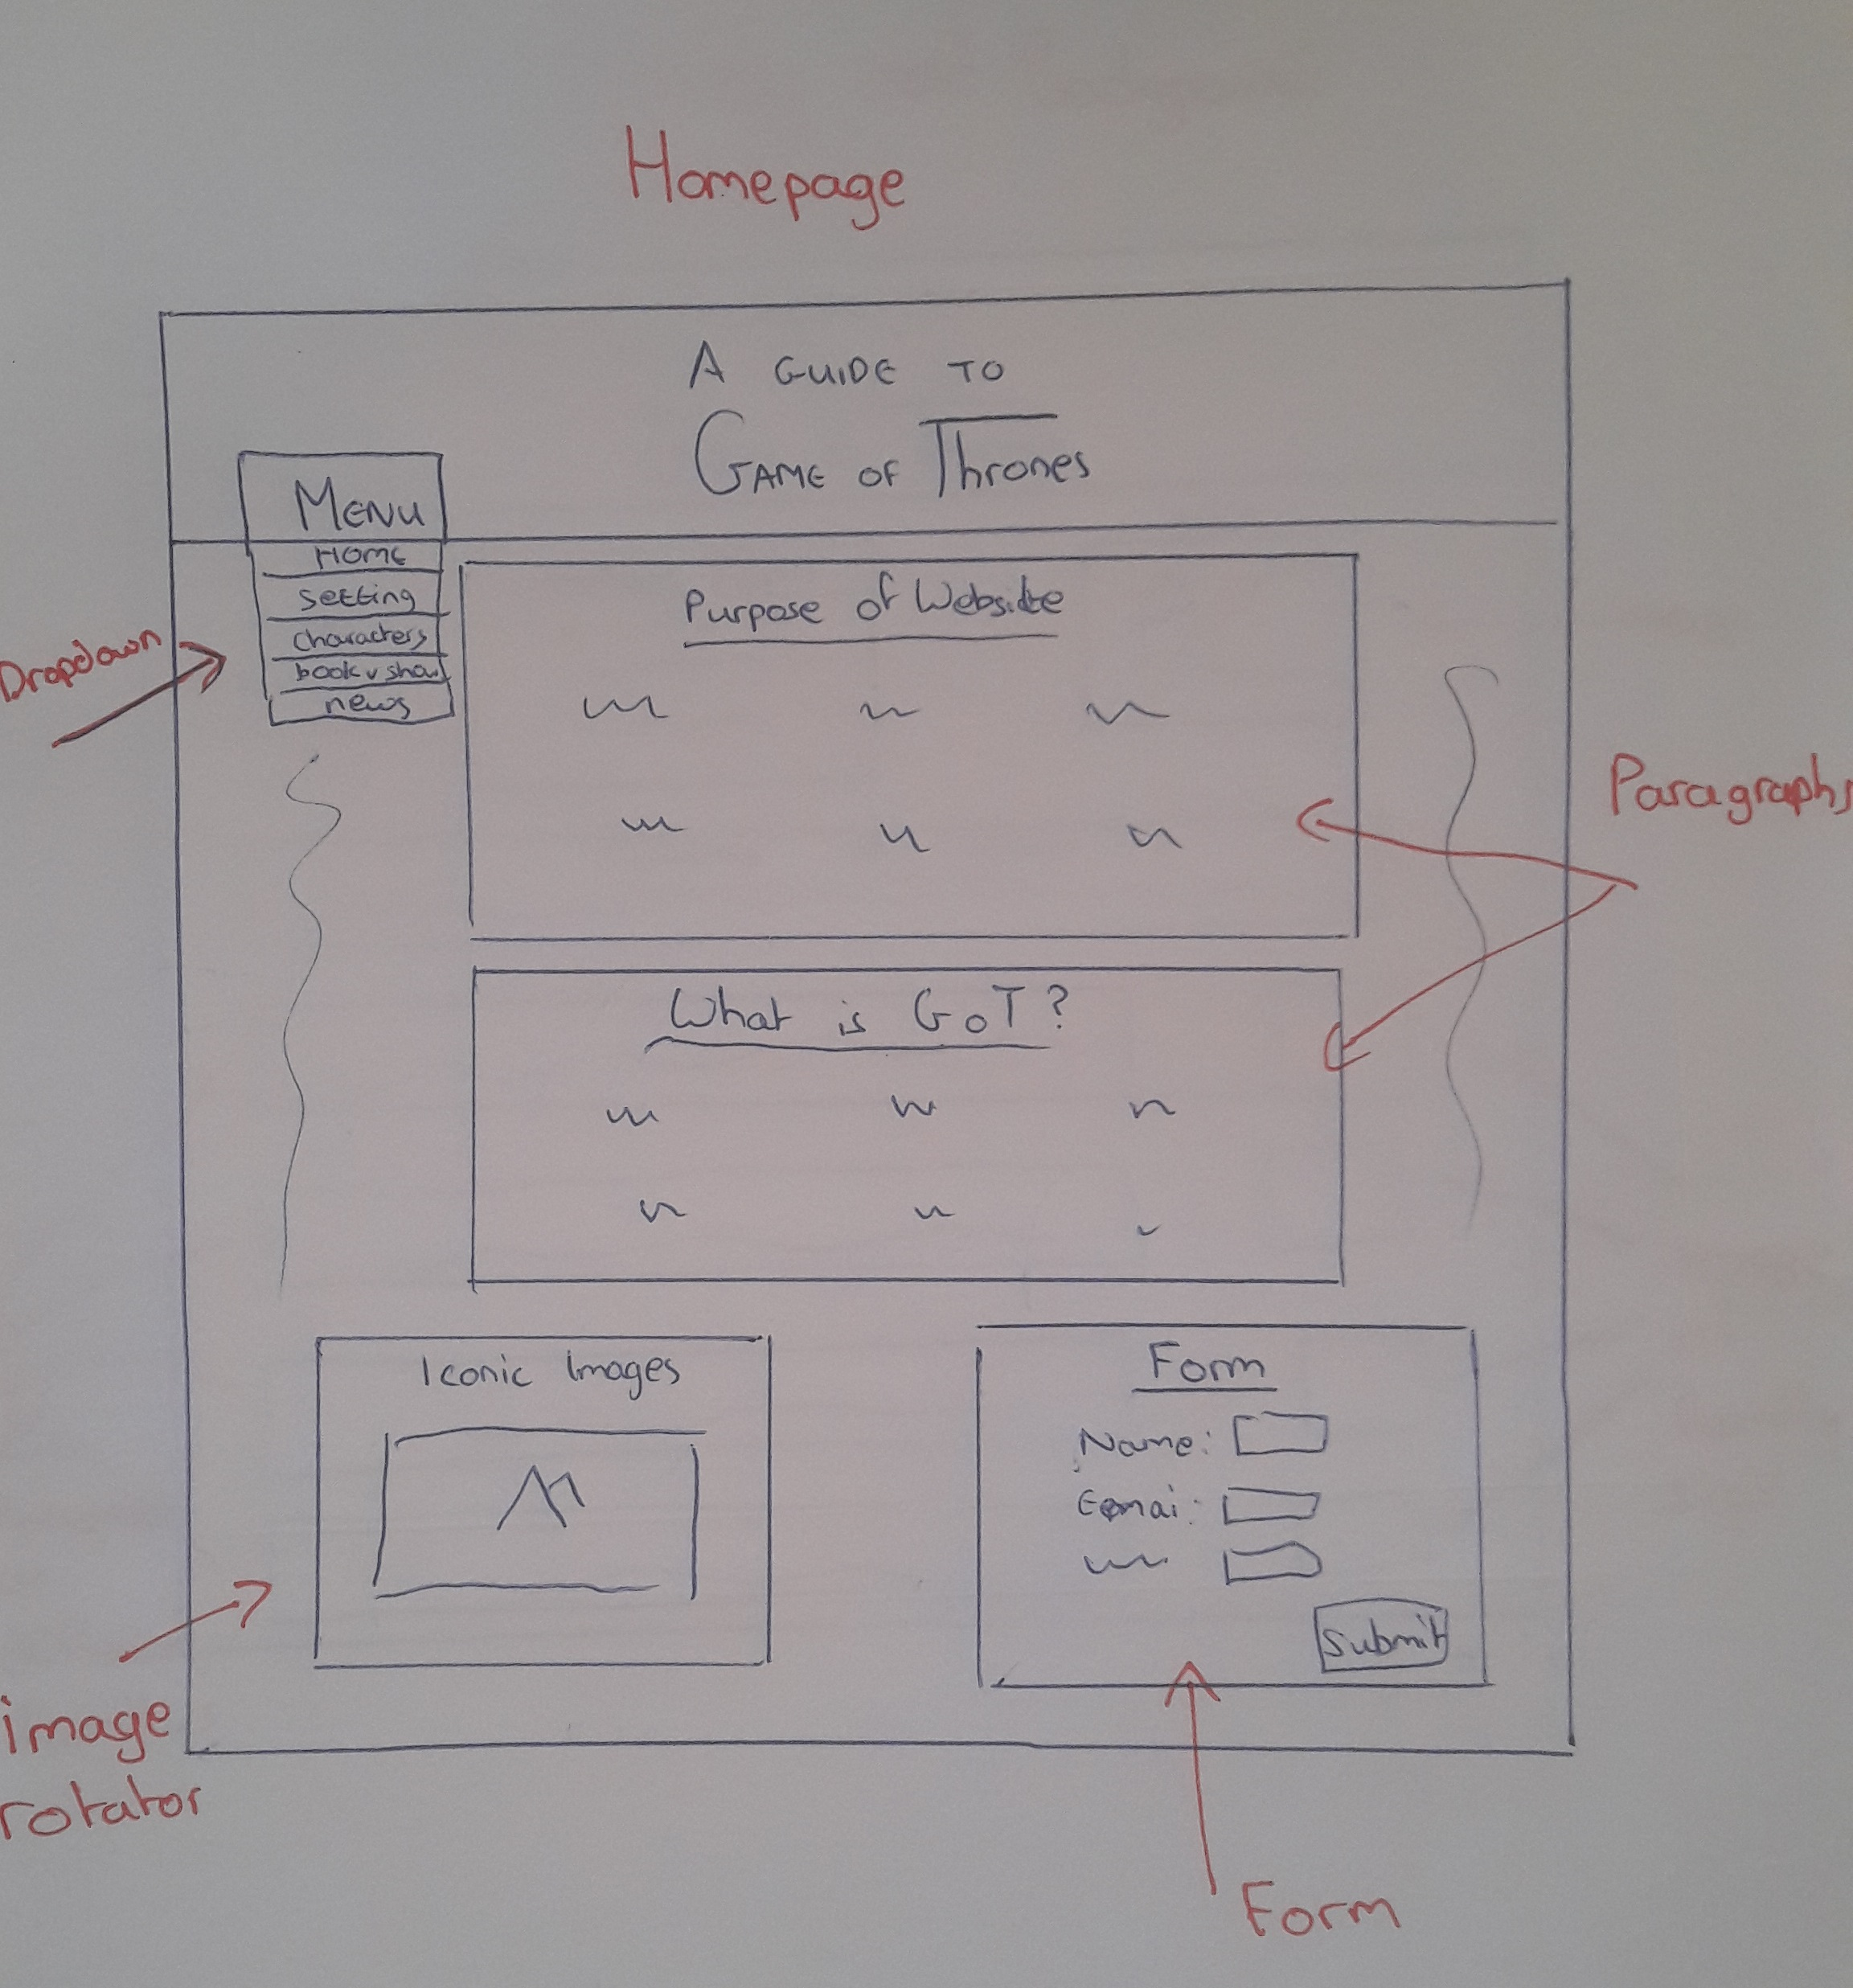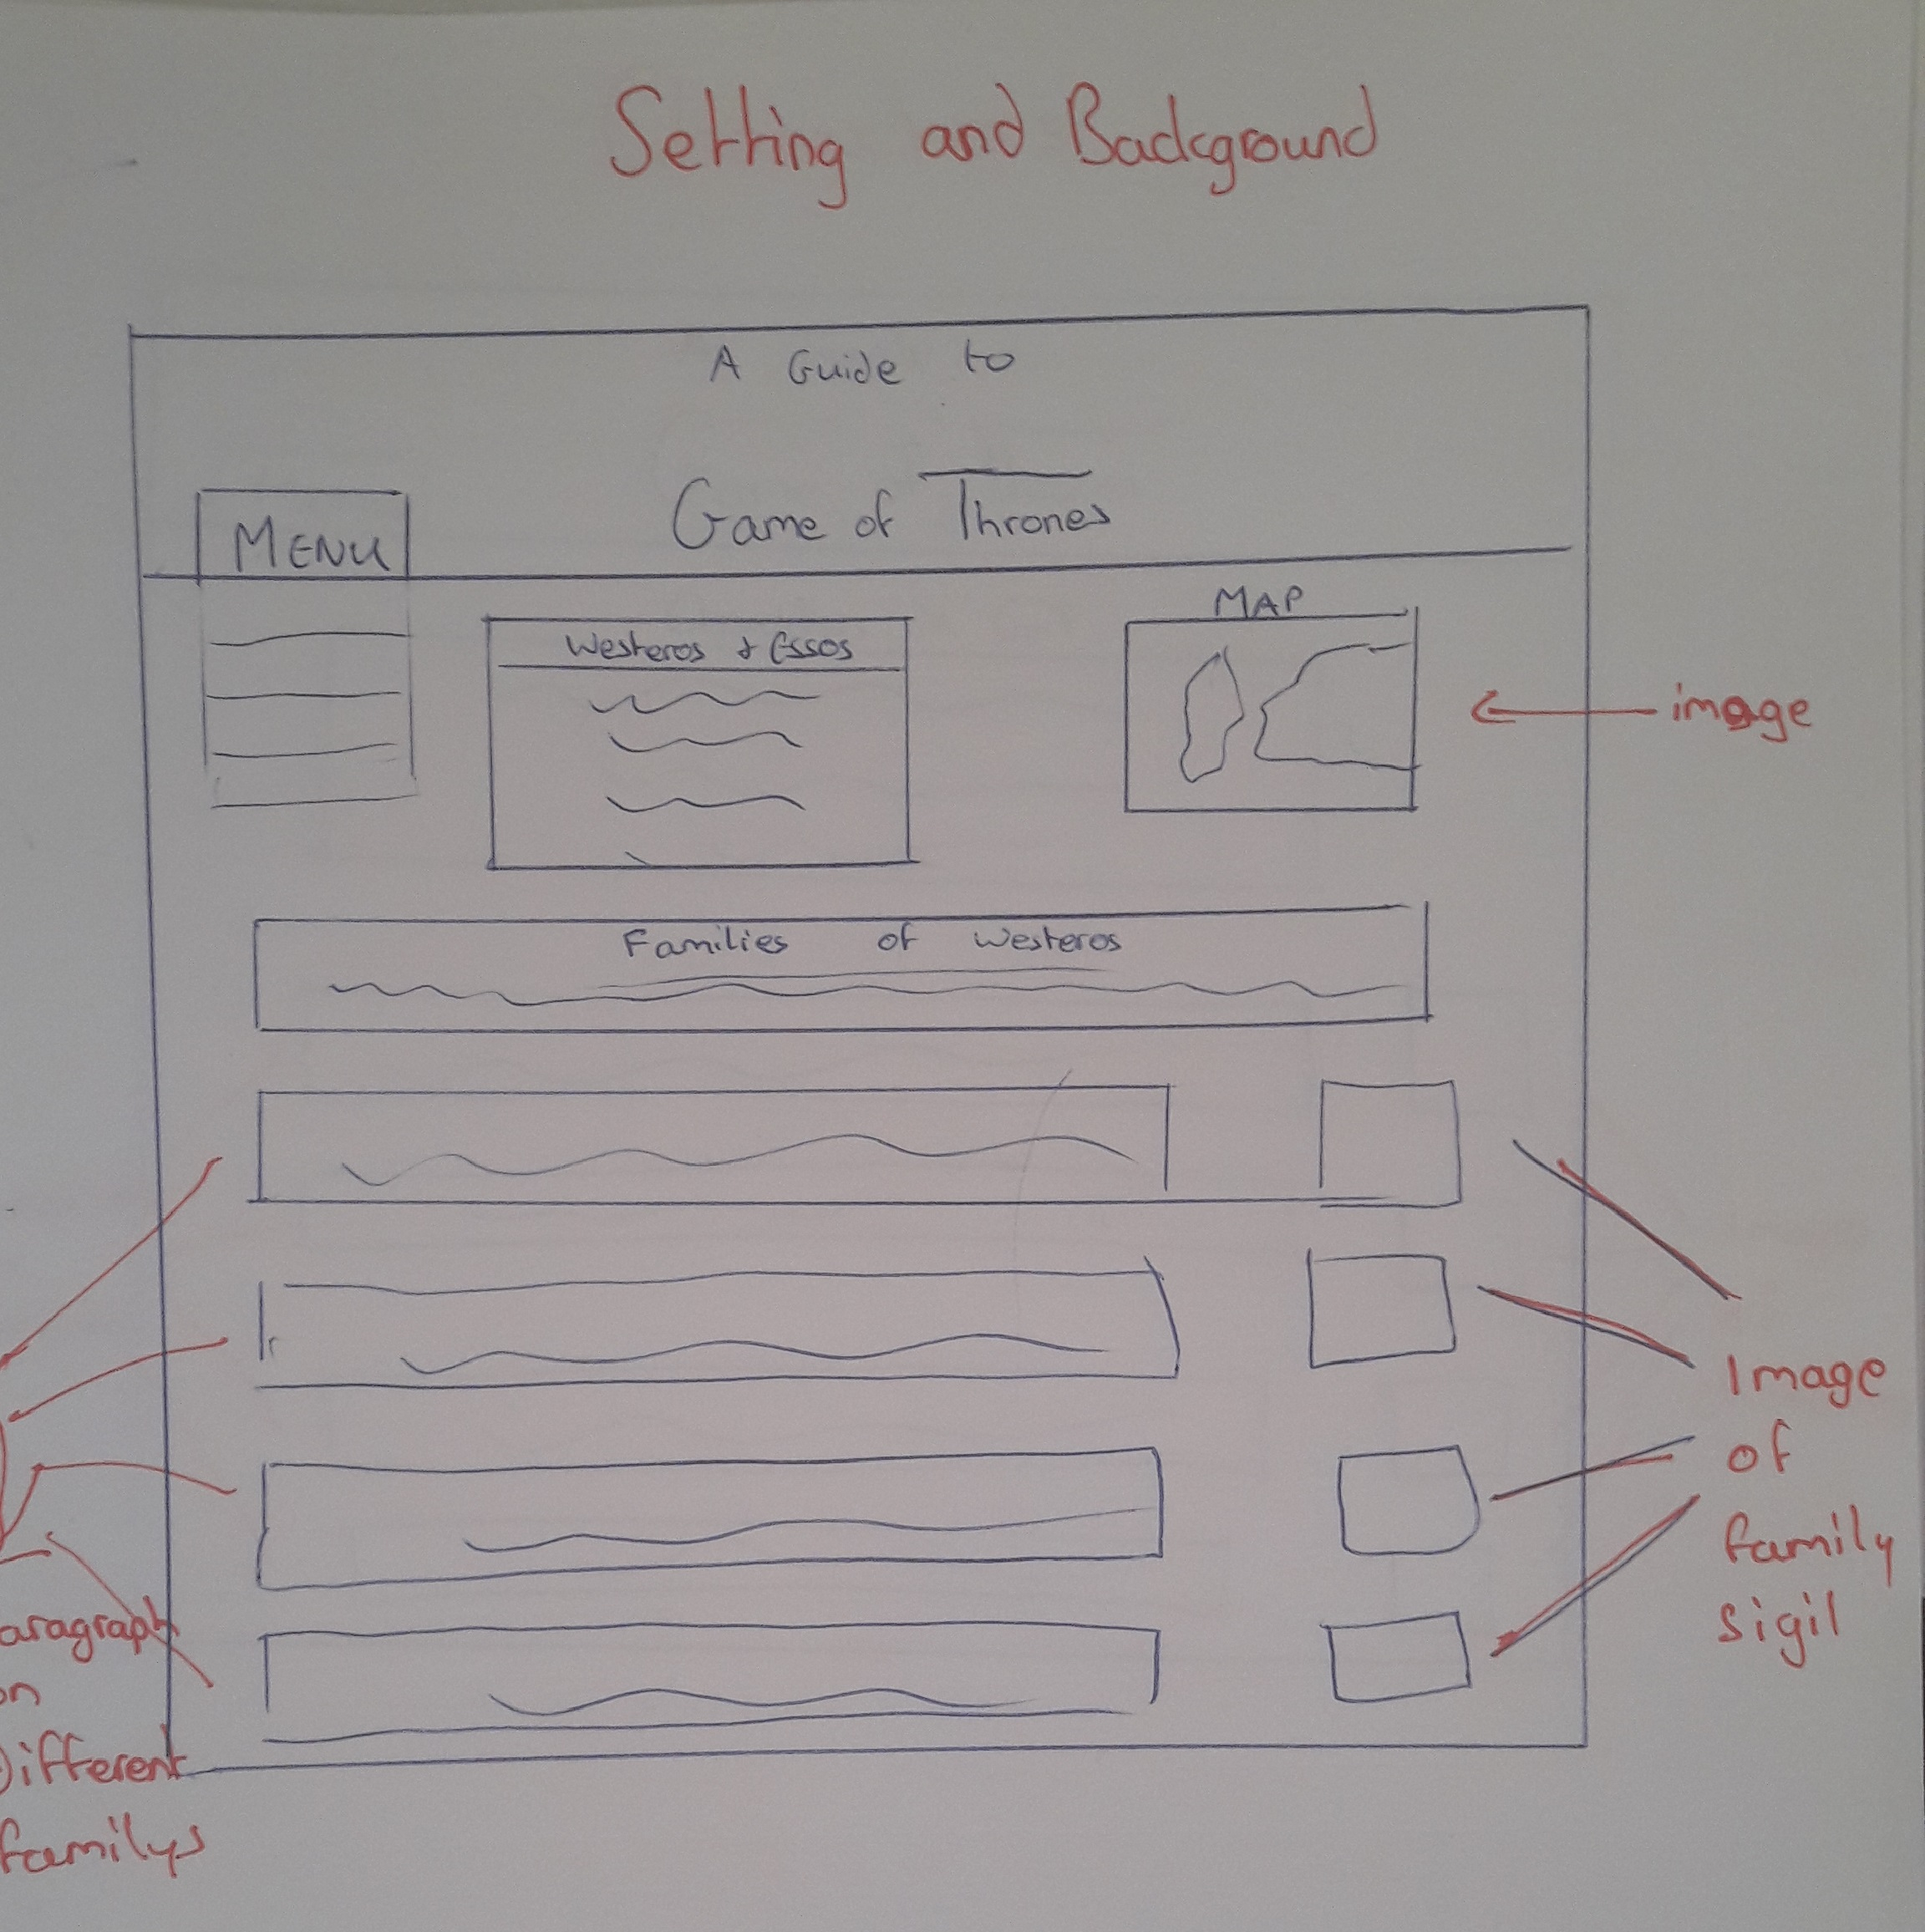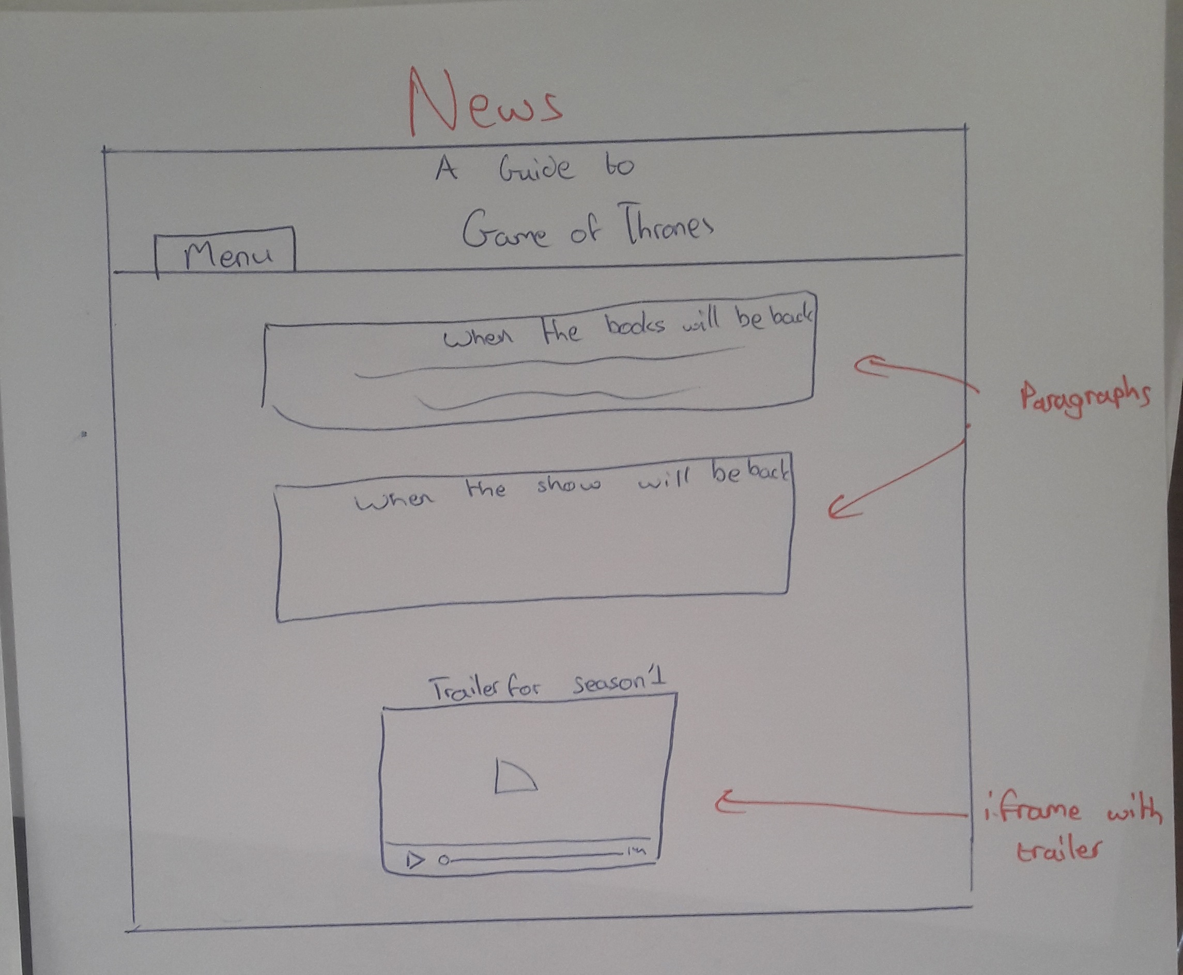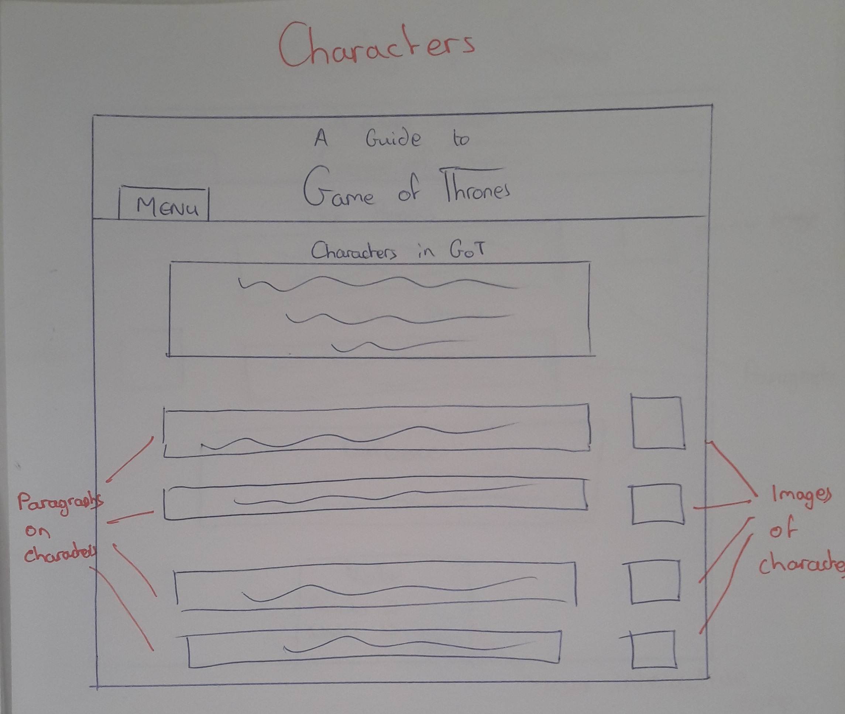**Low Fidelity Prototype**

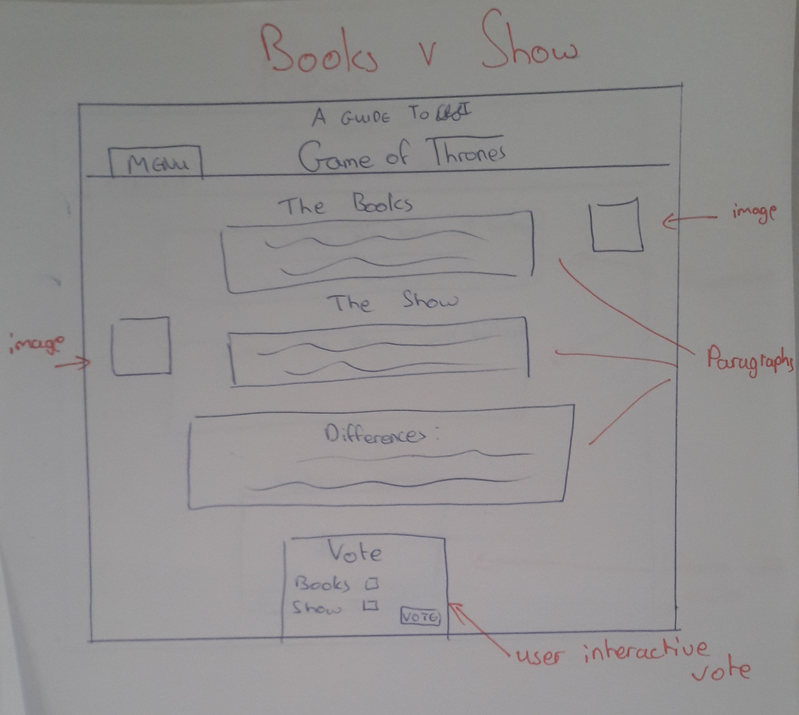

**Evaluation of prototype**

**Visibility of system status:** This was approached through the form, for example if a user does not enter a name a message will appear.

**Match between system and the real world:** Language used was simple and concise for the user. Each topic will be described and explained in order and simple for the user to understand.

**User control and freedom:** The user has full control over where they are on the site and clear headings and links will tell them where they are. If they go somewhere unwanted the simple menu will allow them to navigate back and forth.

**Consistency and standards:** These standards were met as the website is similar to other Game of Thrones websites. The content is easy and simple to follow.

**Error prevention:** Small or little errors could occur on this website as it is simple and mainly has writing.

**Recognition rather than recall:** No recognition was needed for this website

**Flexibility and efficiency of use:** The website caters for everyone as it is very simple to use

**Aesthetic and minimalist design:** The display is appeasing and suited for the content.

**Help users recognize, diagnose, and recover from errors**: not needed

**Help and documentation:** The system is easy to find any problems with.

**Development Plan**

I will start making the website by writing simple html to structure each page of the website. Next I will write up all the information to be included in the website and put them into divs along each page. Next I will use CSS to style each of these paragraphs and position them where I want. Then I will add the photos using html and style them too. By now most of the page is structured how I wanted but I have to add a few things using HTML, CSS and JavaScript at the same time. First I will do the rotating images on the first page and then the form, including validation. Then I will add the Poll on the books vs show page. Once all of this is completed I will run the page through different validators and ensure it works with no errors. Finally I will check that the page is compatible with different browsers.

**Testing Plan**

To test the website I used both HTML and CSS validators. For HTML I used <https://validator.w3.org/> and for CSS I used <http://jigsaw.w3.org/css-validator/>. Both of these were very useful and I quickly found any errors and warning on each. Unfortunately I was unable to fix some of the errors on the form part of HTML as it wouldn’t work without it, and also the Poll caused some errors too which also wouldn’t work without it.

To test if my site was Cross Browser Compatible I opened it on 4 different browsers; Google Chrome, Microsoft Edge, Internet Explorer and Firefox. It gladly worked on all of them showing that my site was Cross Browser Compatible.

**Site Evaluation**

To evaluate my site using appropriate heuristics I first went through Nielsons 10 Usability Heuristics for user interface design, ensuring that my website passed and qualified for each one of them. I then asked my grandmother and little brother, both of which would not be technologically advanced, to try and use the site and thankfully they were able to use it with little trouble.

**Deployment**

Unfortunately I was unable to deploy my website. I tried using webhosting.com and bought a domain. Then I linked this to C panel and used FileZilla to try and upload my files. Unfortunately once I transferred my files to the public_html file, the website would still not appear. The domain was [www.aguidetogameofthrones.com](http://www.aguidetogameofthrones.com) .

# Appendices

**Weekly Logs**

Weekly Project Report – Week 7

For the first week of this project I decided to come up with a plan on how I structure and what will be included on this website. I came up with the idea to do this project on my favourite television show “Game of Thrones”. The website will feature an introduction into the show i.e. a brief description and maybe some included reviews. Then I will give more information on things such as characters, actors, writers, producers etc. The overall aim of the website is to encourage people who haven’t seen the show an incite and incentive to start watching it.

Weekly Project Report – Week 10

For the last two weeks I have been working on the main template for this website. I did this using html and a small bit of css. I laid out each page with a different format but with similar attributes such as the menu bar and eventually the colour scheme. I also started to research what I would be including on each for example; I researched different characters, the writers and history of “Game of Thrones”. I created a word document to write up some key information and paragraphs which I will later import into the website.

I have also started to practise using JavaScript and plan to include changing pictures of characters and scenes. And also a sign up option for more information on the show and notifications on when it is on etc.

Weekly Project Report – Week 12

This week I continued to advance my website. I started adding CSS and creating the design of the 4 pages. I completed the majority of the HTML and have included all the information and writing needed. I just have to tidy up a few things and add a few more details to fully complete the HTML and CSS. I also started to write up some of the report for the website.